Brought to you by the Rhetta Hector – General Manager

**Glasscock Groundwater** Rocio De Luna – Administrative Assistant

**Conservation District** 132 N Main PO Box 208

(432) 354-2430

Website: glasscock-groundwater.org

Email: glasscockgroundwater@yahoo.com

Water Conservation

Conservation is the easiest way to ensure that the entire state has enough water for future growth.

On your lawn:

* The key to watering lawns is to apply water infrequently, yet thoroughly.
* Water before 10 a.m. to save water. Watering in the afternoon increases water loss due to evaporation. While watering in the evening can make your lawn and plants prone to disease.
* A general rule is to water up to 1 inch, once a week. To determine when you have applied enough water, put a 6-ounce tuna can on your lawn. When the tuna can is full you can turn off your water. If you notice runoff before the can is full, turn off the water and wait one hour before you turn it on again. This prevents waste.
  + Replace your irrigation timer to a more efficient control. You can save nearly 7,600 gallons of water!
  + Make sure your sprinklers or hoses are not watering sidewalks or driveways. Sprinklers should spray large drops close to the ground, rather than a mist or fog, which can be blown away by wind.
  + Consider drip irrigation in your flower beds or lawns. Drip irrigation can minimize evaporation and runoff by 60% or more.

In your home:

* + Replace your fixtures with WaterSense products. These small changes can save of 16,000 gallons of water and $200 each year.
  + Replace older toilets with efficient ones. Newer models use as little as 1.28 gallons of water per flush; older models use as much as 6 gallons per flush.
  + 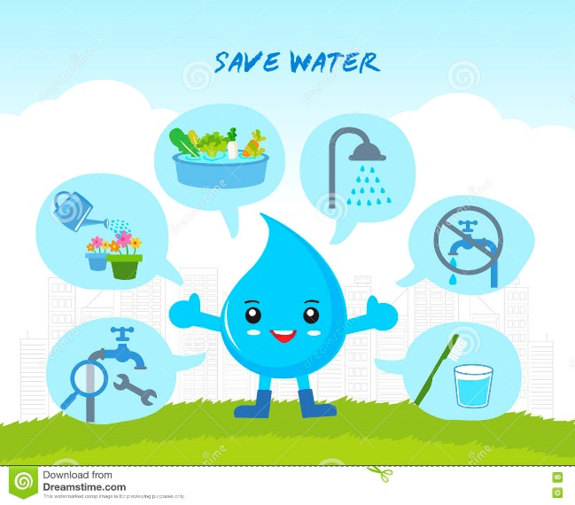Purchase inexpensive aerators for sinks. This inexpensive purchase can save water and are simple to install.
  + You can determine if you have a leak in your home by checking your water meter before and after a two-hour period when no water is used. If the meter changes, you may have a leak.
  + Check your toilet by putting 10 drops of food coloring in the tank. If the color shows up in the bowl within 15 minutes, you have a leak. If you do have a leak, a worn or faulty flapper may be to blame. This easy repair can save up to 200 gallons of water a day.

Conserving Water During Drought & Rainwater Harvesting

Since Texas is a drought prone state, rainwater harvesting is a simple way to collect and use rain when we get it. Lawn and gardens make up 30-50% of total household water use. By collecting rainwater, you can water your lawn without breaking the bank. You can easily collect rainwater by using a rain barrel. If you hook a hose to the bottom of the rain barrel, you can water plants or your lawn during the hot summer months at no cost!

Harvesting rainwater for use in the home landscape: Saves you money by reducing your water bills. Reduces demand on the municipal water supply. Makes efficient use of a valuable resource. Reduces flooding, erosion, and the contamination of surface water with sediments, fertilizers, and pesticides in rainfall runoff.

**Average Rainfall (in inches)**

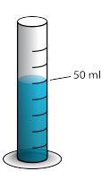**from the GGCD Rain Gauge Network 2024 \***

|  |  |  |  |
| --- | --- | --- | --- |
| January | 0.26 | July | 1.43 |
| February | 0.52 | August | 1.33 |
| March | 0.47 | September | 2.83 |
| April | 0.99 | October | 0.0 |
| May | 2.05 | November | 1.53 |
| June | 0.62 | December | 0.12 |

* based on rainfall numbers provided to the District

Brush Management for Water Conservation

Brush management practice goals should increase water retention in fields. When brush management techniques are used, the following factors should be remembered.

* + The method of brush removal should improve wildlife food supply and habitat.
  + Removal of desirable plant species should be minimal.
  + The amount of brush removal is critical. Drainages or sensitive habitats should always remain intact.
  + Soil disturbance should not be at highly erodible sites. Always consider the topography and soil type.
  + A combination of prescribed fire or mechanical control are ways to reduce unwanted brush and increase water retention.
  + Prescribed burns encourage nutrient cycling having a fertilization effect on the land.
  + Mechanical control should be done in a strip or patchy patterns to retain wildlife nesting and cover needs.

Brush management should always be economically feasible and should plan for periodic maintenance.

Always notify the Sheriff’s Office at (432) 354-2361 before you begin a prescribed burn.